MINISTRY OF EDUCATION AND SCIENCE OF THE REPUBLIC OF KAZAKHSTAN

INTERNATIONAL INFORMATION TECHNOLOGY UNIVERSITY JSC

DEPARTMENT OF COMPUTER ENGINEERING AND INFORMATION SECURITY

**INDUSTRIAL PRACTICE REPORT**

**Major 5В070400 – Computer Systems and Software Engineering**

ТОО «InnoForce CA», apprentice programmer

Done by: Kossaidarova AB. 

«_11_ » __july__2020 (signature)

Head of practice: Yermukhanbetova Sh. _________________

«___ » ______2020 (signature/assignment)

Almaty 2020

International Information Technology University JSC

Department of Computer Engineering and Telecommunications

Major 5В070400 – Computer Systems and Software Engineering

Details of computations and explanations (list of issues due to be addressed):

1. TASK

* Learning programming by:
* completing tasks using Java programming language
* analyzing data from tables using Jupiter Notebook and python libraries
* pass the tutorial from Oracle about web applications

CONTENT

List of terms and abbreviations

1. INTRODUCTION
2. METHOLOGICAL PART  
   2.1 Java programming language
   1. Code examples
   2. Jupiter Notebook
   3. Python libraries
   4. Code examples
   5. Web applications, Bootstrap, Tomcat
3. CONCLUSION
4. REFERENCES

List of terms and abbreviations

INTRODUCTION

LLP «InnoForce CA» is an IT company that provides many kinds of services like: solutions for smartcity, financial technologies and billing systems, development of portal solutions and mobile applications, solutions for customs services, public and private finance management, planning and financial consolidation, automation of public transport and electronic ticketing, automation of dispatching services and rescue services.

Me, as an apprentice programmer, completed tasks that were given by technical director. They were related to learning Java programming language, data analyzing, web applications.

* 1. Java programming language

Java is one of the most popular and widely used programming language. It is object oriented. Also, this programming language is used in many kinds of applications and by using it any logical problem can be solved by creating the functionality.

For example, by using java the problem of counting the amount of water in holes of the surface. Profile of surface is described by array. So be creating the functionality of counting amount of water by analyzing the surface.

* 1. Code examples

1. import java.util.Scanner;  
     
   public class Main {  
    private static Scanner *in* = new Scanner(System.*in*);  
     
    private static int u_o_w_calc(int[] surf_arr) { //Function to calculate the water that should be filled in each array element  
    int u_o_w = 0; //units of water  
    int l = surf_arr.length; //array length  
    int[] left_surf = new int[l]; //array from the left of the actual array  
    int[] right_surf = new int[l]; //array from the right of the actual array  
     
     
    //Storing into the new array from the left of the actual array  
    left_surf[0] = surf_arr[0];  
    for(int i = 1; i < l; i++){  
    left_surf[i] = Math.*max*(left_surf[i - 1], surf_arr[i]);  
    }  
    //Storing into the new array from the right of the actual array  
    right_surf[l - 1] = surf_arr[l - 1];  
    for(int i = l - 2; i >= 0; i--) {  
    right_surf[i] = Math.*max*(right_surf[i + 1], surf_arr[i]);  
    }  
     
    //Summing the water units of the each array in the u_o_w attribute  
    for(int i = 0; i < l; i++) {  
    u_o_w += Math.*min*(left_surf[i], right_surf[i]) - surf_arr[i];  
    }  
     
    return u_o_w;  
    }  
     
    public static void main(String[] args) {  
     
     
    // the program is written to calculate different types of surfaces  
    System.*out*.println("Length of surface array: ");  
    int size = *in*.nextInt();  
     
    int u_of_w = 0; //units of water  
     
    int[] surf_arr = new int [size]; //array storing the surface amount  
     
    System.*out*.println("Surface array elements:");  
     
     
    //filling in the array  
    for(int i = 0; i < size; i++){  
    surf_arr[i] = *in*.nextInt();  
    }  
     
    u_of_w = *u_o_w_calc*(surf_arr); //finding water units by function  
     
    System.*out*.print("How many units of water is needed to fill in the holes of surface: " + "\n" + u_of_w);  
    }  
   }
   1. Data analytics using Python and Jupyter Notebook

Data science is a multidisciplinary field that uses scientific methods, processes, algorithms and systems to extract knowledge and insights from structured and unstructured data.

Python programming language is one of the tools for DS. And as an IDE Jupyter notebook is used. The reason for this is that Jupyter Notebook, as the name already says, works as an notebook that makes it possible to code, so that to analyze data and on the same page write thoughts and conclusions. And all of the written in this notebook looks structured because html and css tools also can be used.

* 1. Python libraries

Analyzing big data cannot be done without using python libraries. And these are two of them that are basic libraries: NumPy and Pandas.

NumPy is used in array-oriented programming. It is suited for many types of applications, like image processing, signal processing, linear algebra, etc. apps. NumPy arrays are dense, continuous, uniformly sized blocks of identically typed data values. So it’s easier to figure out the location of data and the data is more likely to fit in the processor’s cache.

Pandas – an open source, BSD-licensed library providing high-performance, easy-to-use data structures and data analysis tools for the Python programming language. It is built on top of NumPy. Using pandas data can be stored in this type of structures: Series, one-dimensional array, and DataFrames, two-dimensional data structure with labeled axes(rows and columns).

* 1. Code examples

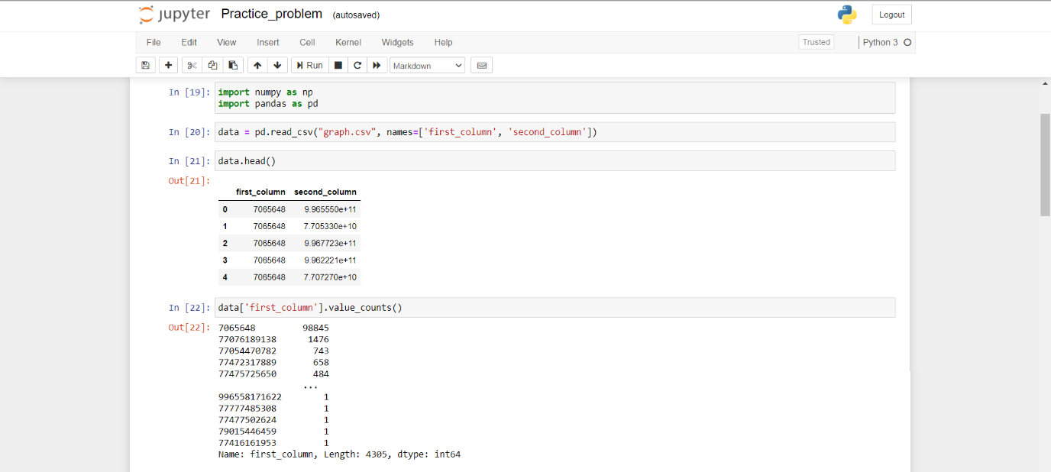

* 1. Web applications, bootstrap, tomcat

A Web application (Web app) is an application program that is stored on a remote server and delivered over the Internet through a browser interface. Tomcat and Bootstrap are tools that can be used to create the web app.

Tomcat is an open source servlet container developed by the Apache Software Foundation. Implements the Servlet Specification, the JavaServer Pages (JSP) Specification, and the JavaServer Faces (JSF) Specification. Written in Java.

Tomcat allows you to run web applications and contains a number of self-configuring programs. Used as a standalone web server.

Bootstrap is a free suite of tools for building websites and web applications. Includes HTML and CSS design templates for typography, web forms, buttons, labels, navigation boxes, and other web interface components, including JavaScript extensions.

CONCLUSION

During the internship I learned more about tools, like Java and Python, that I knew from earlier courses of university. Also, I found out how this tools are used in working process depending on type of job that is being done. In addition, I became familiar with web application creating with embedded Bootstrap and Tomcat.

This professional practice was very useful and efficient. Acquaintance with InnoForce Group and its workflow is important experience for me.

REFERENCES

1. <https://innoforce.kz/> “InnoForce Group” website
2. [https://jupyter.org/](https://jupyter.org/documentation) Information about Jupyter Notebook
3. <https://numpy.org/> Information about NumPy library
4. <https://pandas.pydata.org/> Information about Pandas library
5. <https://searchsoftwarequality.techtarget.com/> Information about Web applications, Tomcat and Bootstrap.